**Chemistry: 11. Plastics**

***Please remember to photocopy 4 pages onto one sheet by going A3→A4 and using back to back on the photocopier***

**Syllabus**

**OC58** Identify everyday applications of plastics, and understand that crude oil products are the raw material for their production

**OC59** Relate the properties of plastics to their use

**OC60** Describe and discuss the impact of non-biodegradable plastics on the environment

**OC61** Understand that chemistry has an important role in pharmacy, medicine and the food industry.

**Student Notes**

**Plastics are made from crude oil**

Crude oil is unrefined oil – it needs to be purified before it can be used.

Remember that oil is a fossil fuel and that fossil fuels are formed from the remains of plants and animals that lived thousands or millions of years ago

**Everyday applications of plastics**

1. Electrical insulation
2. Food containers
3. Packaging
4. Pipes

**Relating the properties of plastics to their use**

|  |  |
| --- | --- |
| **Property** | **Use** |
| Rigid | Furniture |
| Electrical insulators | Wire insulation |
| Flexible | Hose pipes |
| Heat insulators | Polystyrene cups |
| Waterproof | Buckets |

**Non-biodegradable plastics**

**Non-biodegradable plastics do not break down in nature**

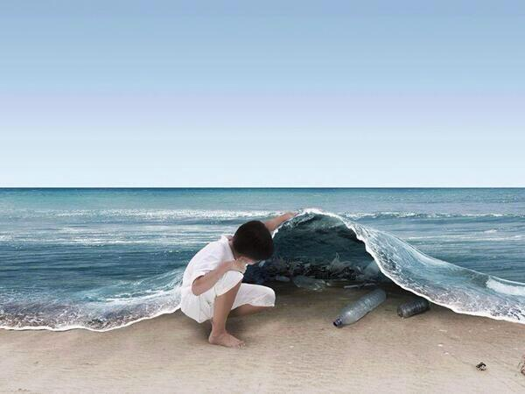

**Impact on the environment**

1. Small pieces of plastic can get eaten by animals and birds on land and by fish in the sea which causes choking.
2. In the sea many fish can get trapped in plastic bags.
3. Plastic gives out an enormous amount of poisonous smoke when burnt which can be fatal in a house fire.

**Exam Questions**



1. [2006 OL][2007 OL][2009 OL][2007][2012 OL]

The picture shows a plastic crate.

Name the raw material used in the making of plastics.

1. [2006 OL][2007][2012 OL]

Most plastics are non-biodegradable. Explain what is meant by the term non-biodegradable.

1. [2009 OL]

Plastics can be non-biodegradable i.e. they do not decompose.

Give one reason why this affects the environment.

1. [2011]

Pollution by non-biodegradable plastics, produced from petroleum, has a significant damaging effect on the environment.

1. Give two of these damaging effects.
2. Explain the term non-biodegradable.

A biodegradable bottle is shown in the image.

Some are made from starch, vegetable oil etc., and are called bioplastics.

Others are made from petroleum with additives.

1. Suggest an advantage of bioplastics over petroleum-based biodegradable plastics.
2. [2007 OL]

Plastics are widely used to make bottles, lunchboxes etc.

Give one reason why plastics are suitable for the uses above.

1. [2006]

Different plastics have different properties.

The dust pan and brush set shown is made from two different plastics.

The bristles are made of type A and the other parts are made of type B plastic.

Give one property of type A and one property of type B plastic that that make them suitable for their use in this product.

**Exam Solutions**

1. Oil
2. These products will not rot (or decay)/ bacteria (or micro-organisms) cannot break them down
3. Do not break down / pollution / persist in the environment / cause litter / unsightly / can damage wildlife
4. Damaging effects: degrades slowly/ burning plastic can release toxic fumes/ large amounts of chemical pollutants are produced by the manufacture of plastics/ large amounts of fossil fuels are use to make plastics/ plastic waste is unsightly in the environment/ expensive to dispose of…
5. Non-biodegradable: will *not* break down/ won't break down for many years/ can’t be broken down by the organisms present on earth.
6. Advantage:made from renewable materials/ no fossil fuels used/ sustainable/ less greenhouse gas(CO2) emissions (reduction in carbon footprint)/ environmentally ‘friendly’/ less hazardous wastes produced in production/ can be composted/…
7. Flexible / mouldable / durable (strong) /hygienic / reusable /recyclable / safer than glass / light / waterproof / doesn’t rot / easier to dye / cheap.
8. A: Flexible/ tough/ hard wearing/strong/ can be formed into fibres (filaments) (bristles)…

B: Can be moulded/ light weight/ rigid/ does not corrode/ colourful…

**Other Test Questions**

1. Give two reasons why items are packed in polystyrene:
2. What advantage does PVC have over wood when used in the manufacture of window frames?